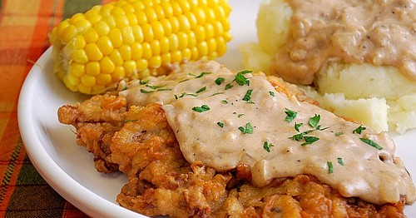

**Chicken Fried Steak & Gravy**

**Ingredients:**

**For The Steaks:**

* 3 cups unbleached all purpose flour
* 1/8 teaspoon cayenne pepper
* 1 large egg
* 1 teaspoon baking powder
* 1/2 teaspoon baking soda
* 1 cup buttermilk
* 6 cube steaks, pounded to 1/3 inch thickness
* cooking oil for frying
* 1 medium onion, minced
* 1/8 teaspoon dried thyme
* 2 cloves garlic, minced
* 3 tablespoons all purpose flour
* 1/2 cup chicken broth
* 2 cups whole milk
* 3/4 teaspoon table salt
* 1/4 teaspoon ground black pepper
* pinch of cayenne pepper

**Method:**

Getting the initial oil temperature to 375 degrees is key to the success of this recipe. An instant-read thermometer with a high upper range is perfect for checking the temperature; a clip-on candy/deep-fry thermometer is also fine. If your Dutch oven measures 11 inches across (as ours does), you will need to fry the steaks in two batches.

**For the steaks:** Measure the flour, 5 teaspoons salt, 1 teaspoon black pepper, and cayenne into a large shallow dish. In a second large shallow dish, beat the egg, baking powder, and baking soda; stir in the buttermilk (the mixture will bubble and foam).

Set a wire rack over a rimmed baking sheet. Pat the steaks dry with paper towels and sprinkle each side with salt and pepper to taste. Drop the steaks into the flour and shake the pan to coat. Shake excess flour from each steak, then, using tongs, dip the steaks into the egg mixture, turning to coat well and allowing the excess to drip off. Coat the steaks with flour again, shake off the excess, and place them on the wire rack.

Adjust an oven rack to the middle position, set a second wire rack over a second rimmed baking sheet, and place the sheet on the oven rack; heat the oven to 200 degrees. Line a large plate with a double layer of paper towels. Meanwhile, heat 1 inch of oil in a large (11-inch diameter) Dutch oven over medium-high heat to 375 degrees. Place three steaks in the oil and fry, turning once, until deep golden brown on each side, about 5 minutes (oil temperature will drop to around 335 degrees). Transfer the steaks to the paper towel-lined plate to drain, then transfer them to the wire rack in the oven. Bring the oil back to 375 degrees and repeat the cooking and draining process (use fresh paper towels) with the three remaining steaks.

**For the gravy:** Carefully pour the hot oil through a fine-mesh strainer into a clean pot. Return the browned bits from the strainer along with 2 tablespoons of frying oil back to the Dutch oven. Turn the heat to medium, add the onion and thyme, and cook until the onion has softened and is beginning to brown, 4 to 5 minutes. Add the garlic and cook until aromatic, about 30 seconds. Add the flour to the pan and stir until well combined and starting to dissolve, about 1 minute. Whisk in the broth, scraping any browned bits off the bottom of the pan. Whisk in the milk, salt, pepper, and cayenne; bring to a simmer over medium-high heat. Cook until thickened (gravy should have a loose consistency—it will thicken as it cools), about 5 minutes.

[source:](http://joelens.blogspot.com/2011/05/chicken-fried-steak-gravy.html)